# **Servlet creation**

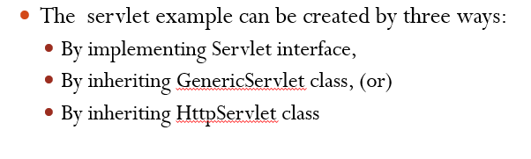

We follow by inheriting the HttpServlet.

# **Servlet methods**

1. init method
2. service/processRequest method
3. destroy method

servlet output (response) will be in the HTML format.

# **Refer basic_helloWorld.java**

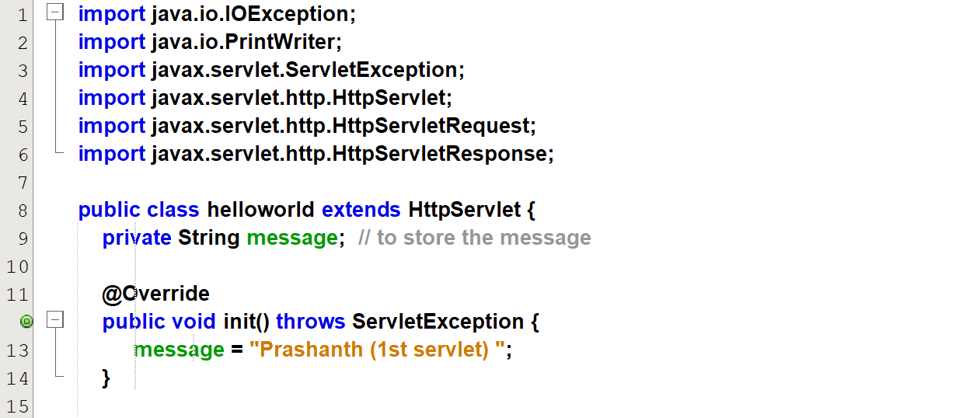  
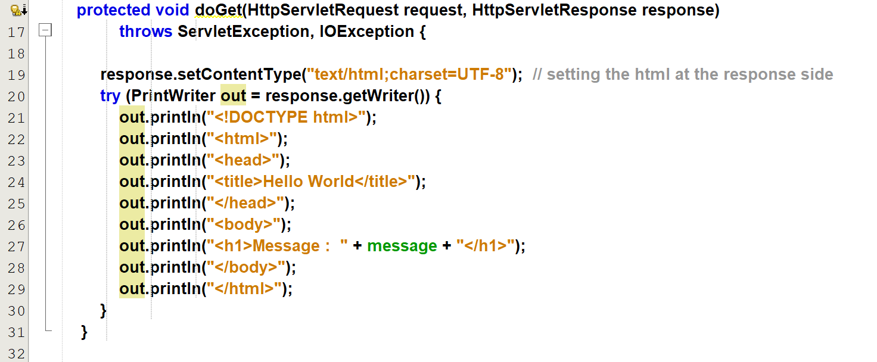  
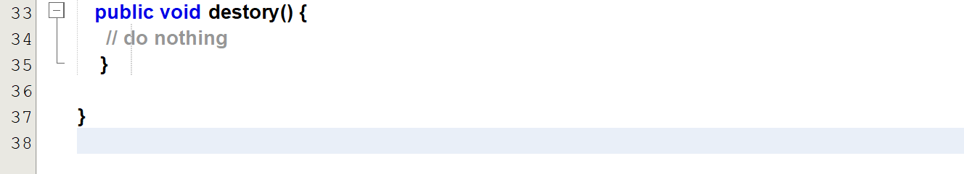



Output  
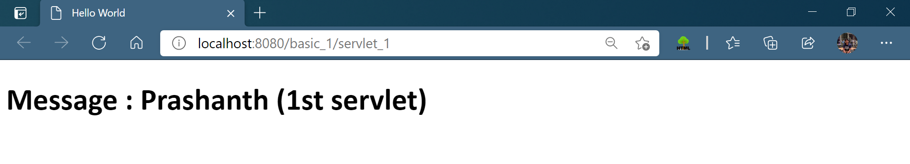

# **Refer basic_form.java**

## Index.html

## (servlet) basic_form.java

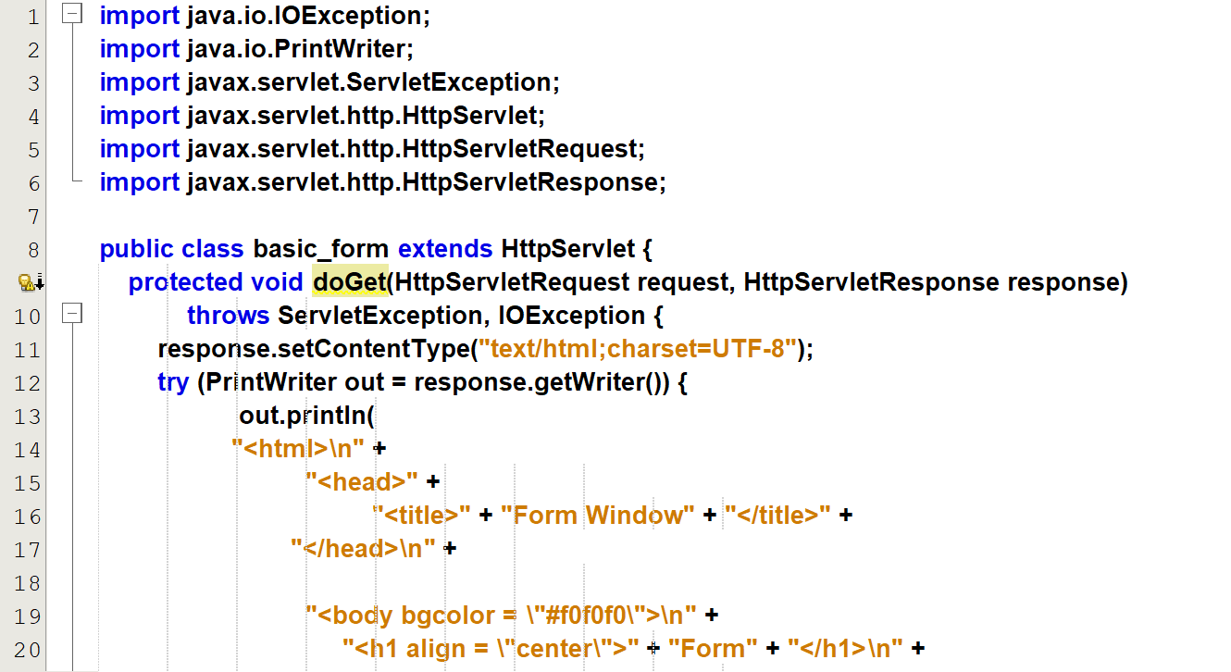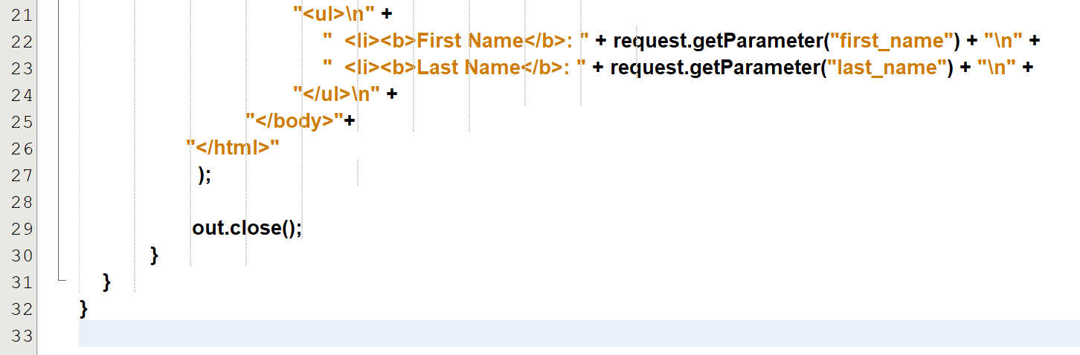

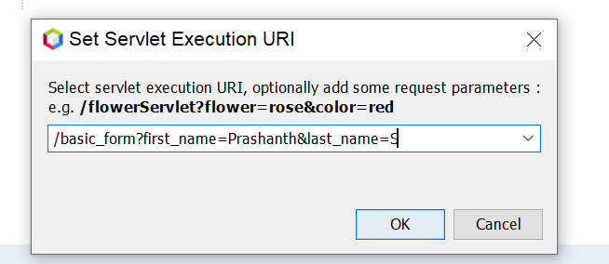

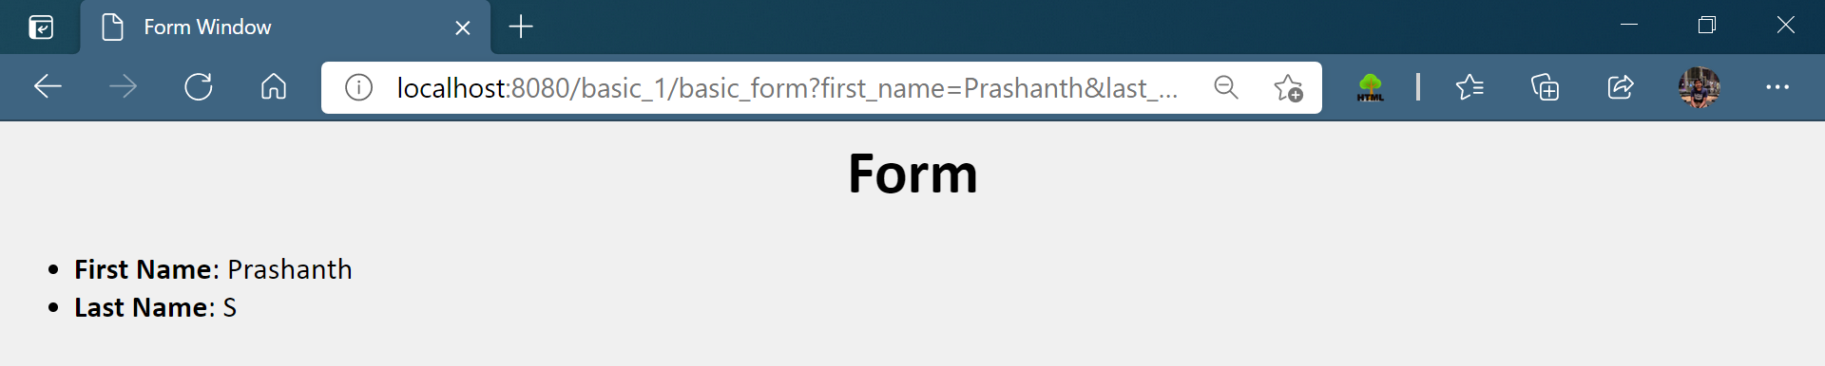

# **Servlets data-base creation**

1. Connection
2. Data-base
3. Tables

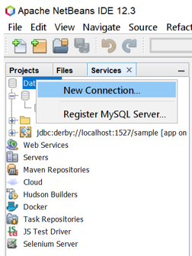

Already the connection for Databases is there.

